Mihin web Review 19th mar 2011

Home page

- The mega banner should have consistency in the text over it…. i.e. text should come in one place throughout all mega banners. See amex home page..
- check the booking engine text, it is not comfortable to the eyes
- have the plane image for quick links
- Have the fares layer permanent or make it appear and disappear. When it is mouse over effect high tendency of customers missing it.
- why fb, twitter and languages links are not on home page
- the down ward arrow mark on menu for booking infor is not available for contact us and about mihin page.
- Ideally careers can come under contact us.
- About Mihin is too short, suggest put the CEO’s photo and a short message explaining mihin and its future strategy for 2011
- how to book link in home page is not working
- Duty free is one of the key selling items and could be used as a good cross selling tool, cant we promote is instead of baggage allowance. Will we get a commission on duty free sales..?? (think well as baggage becomes a product differentiator with other airlines n break the perception budge airlines charge for baggage)
- in some menu items second word start with capital and in some simple letter. Better have consistency

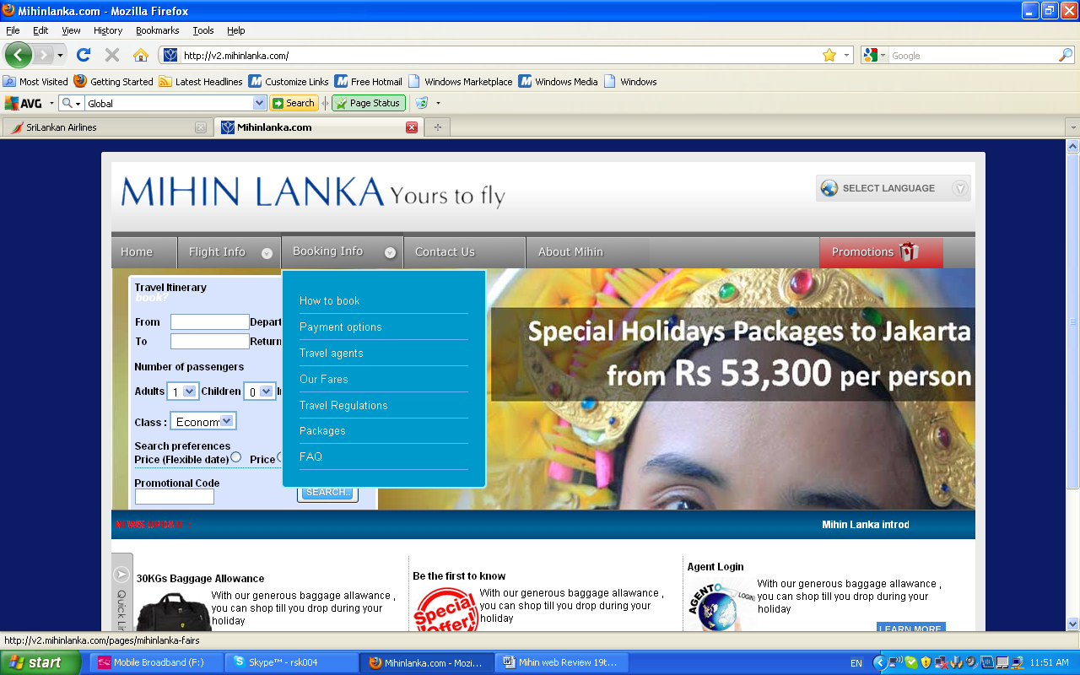

http://v2.mihinlanka.com/destinations/ text inconsistency

http://v2.mihinlanka.com/pages/arrivals-and-departures - text inconsistency

the plane mark should be reversed, in the special Offers link as same as the booking engine. See screenshot below
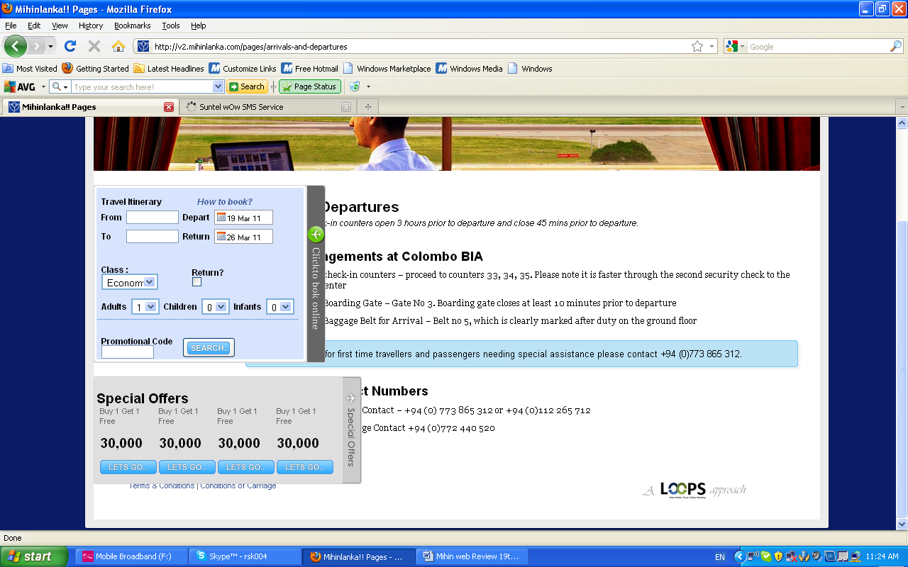

The below screen appears when selecting a duty free item
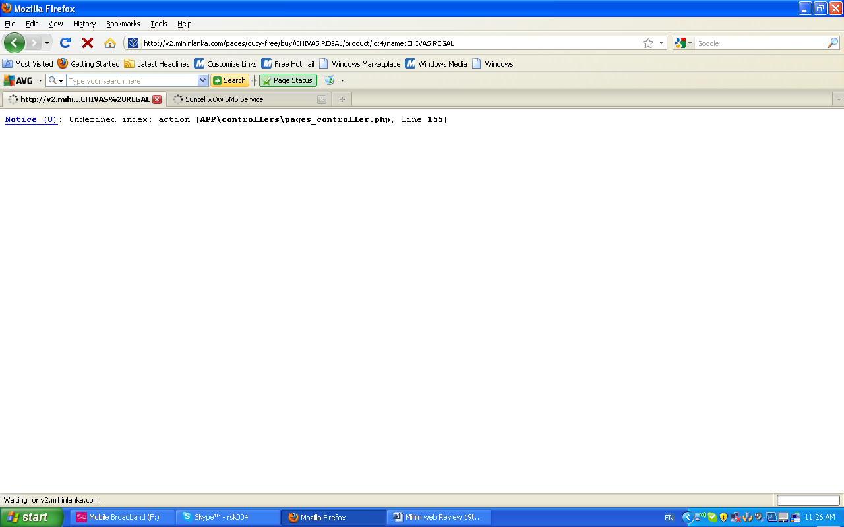

Notice (8): Undefined index: action [APP\controllers\pages_controller.php, line 155]
message is continuing above the menu bar
http://v2.mihinlanka.com/pages/duty-free/buy/CHIVAS%20REGAL/product/id:4/name:CHIVAS%20REGAL

text format is also irregular in the above page

Confirm order, the face sign is purposefully or for fun…
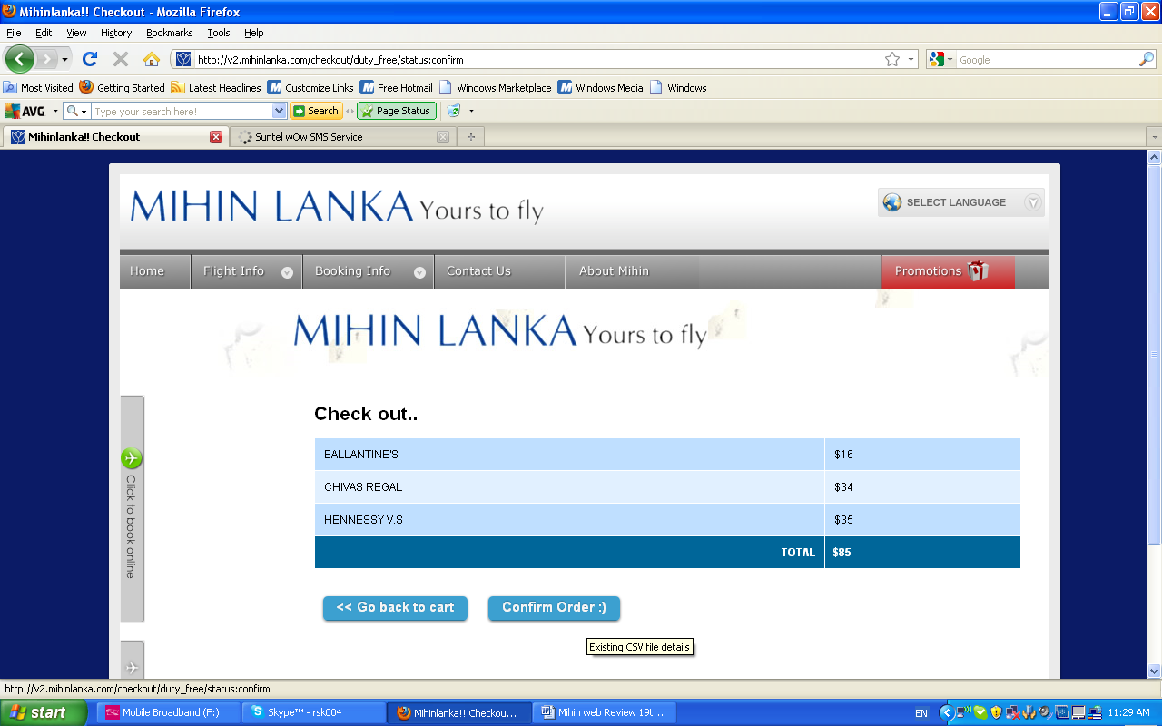

Check out is not working… have we integrated IPG to this page?

http://v2.mihinlanka.com/pages/how-to-book-in-mihinlanka
need paragraph alignement, have oneline on top and then the other facilities. Also link the booking engine to this page

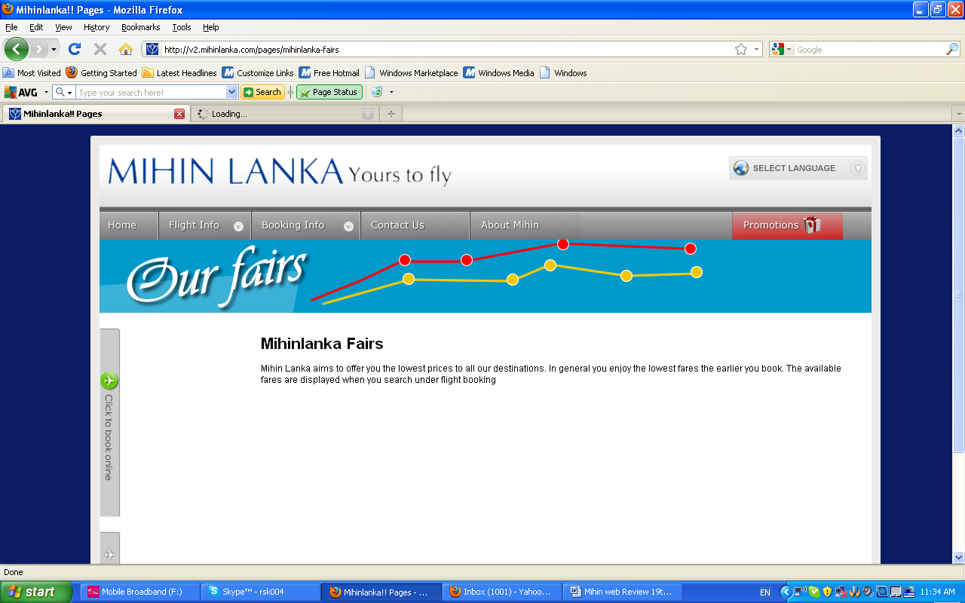
Fares incorrect spelling

- I don’t see any entertainment, does mihin provide this?
- Does mihin sell holiday packages…? It is not shown on web

